ACADEMIC STANDING: A WEB-BASED STUDENT PERFORMANCE MONITORING
SYSTEM WITH ROLE-BASED ACCESS

(A CASE STUDY OF THE DEPARTMENT OF COMPUTER SCIENCE,
CARITAS UNIVERSITY, AMORJI-NIKE, ENUGU)

PROJECT REPORT

BY

UGWU, KENNETH
CS/2022/1218

SUBMITTED TO

THE DEPARTMENT OF COMPUTER SCIENCE
FACULTY OF NATURAL SCIENCES
CARITAS UNIVERSITY, AMORJI-NIKE, ENUGU

IN PARTIAL FULFILMENT OF THE REQUIREMENTS FOR THE AWARD OF
BACHELOR OF SCIENCE (B.SC) DEGREE IN COMPUTER SCIENCE

JULY, 2026

DECLARATION
I, Ugwu, Kenneth, with registration number CS/2022/1218, hereby declare that this project titled “Academic Standing: A Web-Based Student Performance Monitoring System with Role-Based Access” is my original research work carried out under the supervision of Prof. Arinze Nwaeze of the Department of Computer Science, Caritas University, Amorji-Nike, Enugu. The work reported herein has not been presented, in whole or in part, to any institution for the award of any other degree or qualification, and all sources consulted have been duly acknowledged.

________________________________ ____________________
Ugwu, Kenneth Date
(CS/2022/1218)

APPROVAL
This is to certify that we have read, examined and found this project titled “Academic Standing: A Web-Based Student Performance Monitoring System with Role-Based Access”, carried out by Ugwu, Kenneth with registration number CS/2022/1218, to be satisfactory and acceptable for the award of a Bachelor of Science (B.Sc) degree in Computer Science of Caritas University, Amorji-Nike, Enugu, and hence we have caused our names and signatures to appear as follows:

________________________________ ____________________
Prof. Arinze Nwaeze Date
(Project Supervisor)
________________________________ ____________________
Ugwu, Ejike Date
(Head of Department)
________________________________ ____________________
Date
(External Examiner)

DEDICATION
This project is dedicated to Almighty God, the source of all wisdom and understanding, whose grace sustained me throughout this programme; and to my parents, whose sacrifice, encouragement and unfailing support made this academic journey possible.

ACKNOWLEDGEMENTS
I extend my sincere gratitude to God Almighty for the strength, wisdom and good health that sustained me throughout the duration of this project.
My profound appreciation goes to my Project Supervisor, Prof. Arinze Nwaeze, whose guidance, patience and constructive criticism shaped this work from conception to completion.
I am equally grateful to the Head of the Department of Computer Science, Ugwu, Ejike, for his leadership and support throughout the programme. My sincere thanks go likewise to Dr. Henry Nweke and Dr. Ugochukwu Nwankwo, and to all the other lecturers of the Department of Computer Science, Caritas University, Amorji-Nike, Enugu, for the knowledge they imparted over the course of my study.
Finally, I acknowledge my family, friends and course mates for their moral and financial support, for testing the system and offering feedback on its usability, and for their steadfast encouragement during the development of this work.

ABSTRACT
This work reports on Academic Standing, a web-based student performance and academic standing monitoring system developed for the Department of Computer Science, Caritas University, Amorji-Nike, Enugu. It examined the manual, release-bound method by which student standing was previously determined and used the findings to design a role-based alternative for the head of department, lecturers and students. The system computed semester and cumulative grade point averages and degree classification on the five-point scale, ranked at-risk students through a rule-based scoring engine, correlated attendance with performance, and projected the grades required for a target classification. It was designed using the Object-Oriented Analysis and Design Methodology and implemented in HTML, CSS and JavaScript.

TABLE OF CONTENTS
(In Microsoft Word, press Ctrl+A then F9 and choose “Update entire table” to populate this table of contents with the correct page numbers.)

CHAPTER ONE

INTRODUCTION

1.1 Background of the Study
The academic standing of a student is the single most consequential summary the university produces about that student. Expressed as a cumulative grade point average (CGPA) on the five-point scale used across Nigerian universities, it determines eligibility to progress, exposure to probation and withdrawal, and ultimately the class of degree awarded. For the institution, the distribution of standing across a department is an equally important measure: it indicates how many students are on course to graduate in good standing, how many are drifting toward failure, and where along the curriculum the greatest difficulty lies.
For all its importance, academic standing has historically been visible only in retrospect. Under the conventional arrangement, a student learns their position only when results are released at the end of a semester, by which time the semester that produced the result is already over and no corrective action is possible within it. The computation itself is performed manually or in spreadsheets by departmental staff, is available to the student as a single figure rather than as an interpretable picture, and yields no early signal to anyone that a particular student is falling behind while there is still time to intervene.
Advances in web technologies now make it feasible to close this gap without significant expenditure. A grade point average is an arithmetic function of scores and credit units; a degree classification is a lookup against fixed bands; the relationship between attendance and performance is a standard correlation; and the projection of the average a student must achieve to reach a target class is elementary algebra. Each of these can be computed in the browser and presented, the moment a score is known, to the person who needs it — the lecturer entering the score, the student whose standing it affects, and the head of department responsible for the cohort.
This study therefore proposes Academic Standing, a web-based student performance and academic standing monitoring system for the Department of Computer Science, Caritas University, Amorji-Nike. The system presents three role-appropriate workspaces. The head of department sees a department overview with mean standing, an at-risk register and the correlation of attendance with performance. The lecturer sees only the courses they teach, with a score sheet whose totals, grades and grade points are computed as scores are entered, and a distribution of the class. The student sees their own standing, degree classification, semester trend, strengths by subject area and a projection of what remains to reach a chosen class of degree. In doing so, the system replaces a retrospective, single-figure, release-bound arrangement with a continuous, interpretable and role-scoped one.

1.2 Statement of the Problem
At the Department of Computer Science, Caritas University, Amorji-Nike, a student’s academic standing is computed manually or in spreadsheets and becomes known only after end-of-semester results are released. Because the figure arrives after the semester that produced it has ended, neither the student nor the department can act on it in time to change the outcome it reports.
This arrangement produces several related difficulties. A student receives their CGPA as a bare number, without any indication of the class of degree it corresponds to, the trajectory it sits on, or the effort required to improve it. The department possesses no mechanism for identifying, ahead of results, which students are drifting toward failure, so support is offered late or not at all. No routine analysis links attendance to performance, although the two are known to be related, and no per-course view reveals which courses are failing the greatest number of students. Consequently, decisions about intervention, support and curriculum are taken without the evidence needed to direct them. There is a clear need for a system that computes standing continuously and presents it, in an interpretable and role-appropriate form, to each party who can act on it. This study develops such a system.

1.3 Aim and Objectives of the Study
The aim of this study is to develop a web-based student performance and academic standing monitoring system that gives the department, its lecturers and its students an early, interpretable and role-appropriate view of academic standing before results are formally released. The specific objectives are to:
1. Design the architecture and role model of a web-based academic standing system serving three actors: the head of department, the lecturer and the student.
2. Develop a role-based access mechanism that scopes every actor to the data appropriate to their role — department-wide for the head of department, own-courses for the lecturer, and self for the student.
3. Implement the automatic computation of semester grade point average, cumulative grade point average and degree classification on the Nigerian five-point scale.
4. Implement a lecturer score sheet that computes each student’s total, letter grade and grade point as continuous-assessment and examination scores are entered.
5. Implement a rule-based at-risk scoring engine that ranks students by a transparent composite of CGPA shortfall, semester GPA decline, attendance shortfall and outstanding carryovers.
6. Implement a degree-class projection facility that computes the grade point average a student must achieve across their remaining units to reach a chosen classification.
7. Implement department-level analytics, including the correlation of attendance with CGPA and a course difficulty index reporting mean score, spread and failure rate per course.
8. Evaluate the functionality, usability and responsiveness of the developed system using representative departmental users.

1.4 Significance of the Study
The completion of this study carries practical benefit for several groups within the university community.
For students, the system converts a single, retrospective figure into an interpretable and forward-looking picture. It shows not only the current CGPA but the class of degree it corresponds to, the semester-by-semester trajectory that produced it, the subject areas in which the student is strong or weak, and — most usefully — the grade point average required across remaining courses to reach a target class. A student can therefore act on their standing while there is still time to change it.
For lecturers, the system removes the arithmetic of grading. Totals, letter grades and grade points are computed as scores are entered, and the distribution of the class is displayed alongside, so that a lecturer sees immediately how a cohort has performed and how many students have failed.
For the head of department, the system produces, for the first time, a continuous department-level view: the mean standing of the cohort, the proportion in good standing, a ranked register of the students most at risk, the correlation between attendance and performance, and an index of which courses fail the most students. Decisions on intervention, support and curriculum that were previously taken without evidence can now be directed by it.
For the academic community, the study demonstrates the practical construction of an academic early-warning and analytics system appropriate to the data and infrastructure of a Nigerian university department, and provides a reference implementation that may be extended by future researchers.

1.5 Scope of the Study
This study covers the design, implementation and evaluation of a web-based academic standing monitoring system for the Department of Computer Science, Caritas University, Amorji-Nike. The system provides three role-scoped workspaces. The head-of-department workspace presents a department overview, a filterable at-risk register, a course difficulty index and a searchable student record. The lecturer workspace presents the courses the lecturer teaches, a score sheet with live computation of totals, grades and grade points, and a grade distribution. The student workspace presents personal standing, degree classification, a semester GPA-and-CGPA trend, strengths by subject area, a degree-class projection and an attendance view. Every computation is recomputed as at a selected academic session, so that the session control is a genuine filter rather than a label.
The study is bounded as follows. It concerns the computation, monitoring and presentation of academic standing, and does not extend to the administration of examinations or the formal issuance of results, which remain the responsibility of the university’s examination system. It operates on a self-contained departmental dataset generated within the application to demonstrate every view at realistic scale; connection to the university’s live result database is identified as further work rather than undertaken here. It does not include the recruitment, timetabling or payroll functions of a full departmental information system, these being administrative rather than academic-standing matters.

1.6 Limitations of the Study
Several factors constrained the execution of this work and should be borne in mind when interpreting its results.
First, the system is a functional prototype operating on a generated departmental dataset rather than on live institutional records. The one hundred and forty-eight student records, their results across every semester, their attendance and their carryovers are produced within the application by a deterministic generator, so that the figures are realistic and stable across reloads but are not those of real students. The computation of GPA, CGPA, classification, risk score, correlation and projection is nevertheless fully implemented and operates on this dataset exactly as it would on real records, so that connecting the university result database would require substitution of the data source rather than redesign of the system.
Second, the prototype does not yet persist changes. When a lecturer amends a score in the score sheet, the total, grade and grade point are recomputed immediately, but the amendment is not written to a store and does not survive a reload, because no server-side database is provisioned in this build. The introduction of a persistence layer is identified in section 5.3 as a priority for further work.
Third, authentication in the present build is performed within the browser against a small set of demonstration accounts, and is intended to exercise the role-based access design rather than to secure real accounts. Server-side credential verification against irreversibly hashed values is likewise identified as further work.
Fourth, the study was carried out within a single academic session alongside coursework and examinations, which constrained the duration of the evaluation exercise and the number of respondents who could be engaged.

1.7 Definition of Terms
Academic Standing: the overall academic position of a student at a given point in their programme, expressed principally through the cumulative grade point average and the degree classification it falls within.
Grade Point Average (GPA): the credit-weighted average of the grade points earned by a student in the courses of a single semester.
Cumulative Grade Point Average (CGPA): the credit-weighted average of the grade points earned across all semesters completed to date.
Grade Point: the numeric value assigned to a letter grade on the five-point scale, ranging from five for an A to zero for an F.
Degree Classification: the class of degree corresponding to a band of CGPA, namely First Class, Second Class Upper, Second Class Lower, Third Class, Pass or Below Pass.
Carryover: a course previously failed that a student must repeat, which continues to affect the cumulative average until passed.
At-Risk Student: a student whose composite risk score, derived from academic standing, recent trend, attendance and carryovers, indicates a material likelihood of academic difficulty.
Risk Score: a rule-based composite measure, expressed from zero to one hundred, that ranks students by their exposure to academic difficulty.
Role-Based Access: a design in which the data and functions available to a user are determined by their assigned role, so that each user sees only what their role permits.
Course Difficulty Index: a per-course summary of mean score, spread and failure rate, used to identify the courses in which students most often fail.
Correlation: a statistical measure, here the Pearson coefficient, of the strength and direction of the relationship between two quantities, such as attendance and CGPA.
Responsive Web Application: a web application whose interface adapts automatically to the screen dimensions of the device on which it is viewed.
CHAPTER TWO

LITERATURE REVIEW

2.1 Introduction
This chapter reviews the body of literature relevant to the design of a web-based academic standing and student performance monitoring system. It begins by establishing the conceptual boundaries of academic analytics and early-warning systems and the functional components common to them. It then examines the theoretical accounts of student attrition and of technology acceptance that bear on the work, before turning to the technical foundations on which such systems rest: performance prediction and risk identification, the relationship between attendance and achievement, and the presentation of academic analytics. The chapter then reviews a body of related empirical works, each with its contribution and its limitation, and concludes by identifying the gap in existing knowledge that the present study addresses.

2.2 Conceptual Framework

2.2.1 Learning Analytics and Educational Data Mining
The use of student data to understand and improve learning is organised in the literature under two closely related headings. Siemens and Long (2011) define learning analytics as the measurement, collection, analysis and reporting of data about learners and their contexts for the purpose of understanding and optimising learning and the environments in which it occurs. Educational data mining, reviewed comprehensively by Romero and Ventura (2010, 2020), applies data-mining methods to the same data to discover patterns not evident by inspection. The distinction is one of emphasis rather than of kind: learning analytics foregrounds reporting to human decision-makers, while educational data mining foregrounds automated discovery. The present system sits on the learning-analytics side of this distinction, since its purpose is to report standing and risk to the department, its lecturers and its students in a form on which they can act.

2.2.2 Academic Early-Warning Systems
An academic early-warning system is one that identifies students at risk of failure or withdrawal in time for intervention. Arnold and Pistilli (2012) describe Course Signals, an early-warning system deployed at Purdue University that combined performance, effort and background into a risk indicator surfaced to students and instructors, and reported measurable improvements in grades and retention among cohorts exposed to it. Their work establishes the central proposition on which the present study rests: that surfacing risk early, in an interpretable form, changes outcomes. The system developed here adopts this proposition while deliberately using a transparent rule-based indicator in place of an opaque predictive one, so that every risk score can be explained to the student it concerns.

2.2.3 Functional Components of a Performance-Monitoring System
Across implementations, academic performance-monitoring systems exhibit a recurring set of components. A grading component converts raw scores into grades, grade points and averages. A classification component maps a cumulative average to a degree class. A risk component combines indicators into a measure of academic exposure. An analytics component aggregates across a cohort to reveal distribution, correlation and difficulty. A presentation component renders each of these to the appropriate audience, and an access component restricts what each audience may see. The system developed in this study implements each of these components, with the grading, classification, risk, analytics and access components operating over a generated departmental dataset.

2.3 Theoretical Framework

2.3.1 Tinto’s Model of Student Attrition
Tinto (1975) advanced the most influential theoretical account of why students leave higher education before completing, arguing that departure is the outcome of a longitudinal process in which academic and social integration determine a student’s commitment to completion. The model bears on the present work in two ways. It establishes that academic difficulty is rarely sudden, developing instead over a trajectory that is in principle observable before it culminates in failure — which is precisely what a semester-by-semester standing trend makes visible. It further implies that the value of an early-warning system lies in acting during that trajectory rather than at its end, which motivates the system’s emphasis on presenting standing continuously rather than only at graduation.

2.3.2 The Technology Acceptance Model
The Technology Acceptance Model, formulated by Davis (1989), remains the most widely applied account of why individuals adopt or reject an information system, holding that adoption is governed chiefly by perceived usefulness and perceived ease of use. The model bears directly on a system intended for three distinct audiences. A head of department will adopt the overview only if it surfaces something not already known; a lecturer will adopt the score sheet only if it is faster than the spreadsheet it replaces; a student will consult their standing only if it is clearer than the figure they already receive. These considerations informed several design decisions, notably the live computation of grades in the score sheet, the interpretation of every CGPA into a degree class, and the projection facility that turns a standing into an actionable target.

2.4 Predicting and Identifying Student Performance
A substantial literature addresses the prediction of student performance from prior and concurrent data. Kotsiantis, Pierrakeas and Pintelas (2003) applied machine-learning classifiers to predict dropout in distance learning, establishing that even modest attributes available early in a course carry predictive signal. Shahiri, Husain and Rashid (2015) reviewed the field and found CGPA and internal assessment to be among the most consistently used and most predictive attributes across studies. Asif, Merceron, Ali and Haider (2017) analysed undergraduate performance across a full degree programme and showed that early-year results are strongly indicative of final standing, supporting interventions targeted at students identified in the early years. This body of work justifies the attributes the present system combines into its risk score — standing, trend, attendance and carryovers — while the system departs from it in using a transparent rule-based combination rather than a trained classifier, a choice appropriate to a setting where the score must be explained and where a validated training corpus does not yet exist.

2.5 Attendance and Academic Achievement
The relationship between class attendance and academic achievement is among the most firmly established in the education literature. Credé, Roch and Kieszczynka (2010), in a meta-analysis spanning many studies and institutions, found attendance to be a strong predictor of both course grades and overall grade point average, stronger indeed than most other known predictors of performance. This finding provides the empirical warrant for the present system’s treatment of attendance as a first-class indicator: attendance is both a component of the risk score and the subject of a dedicated correlation, computed and displayed for the department as a whole and for each student against their cohort. The system does not assert causation from this correlation; it presents the coefficient and leaves its interpretation to the user.

2.6 Presentation of Academic Analytics
The value of an analytic figure depends on its presentation. Baker and Inventado (2014) note that the impact of educational data mining and learning analytics is realised only when results reach the people positioned to act on them, in a form they can interpret. This consideration shaped the presentation decisions of the present system: a CGPA is never shown as a bare number but is always placed on a classification scale that names the class it falls within and the gap to the next; a class distribution is shown as a spread rather than a mean alone; a course’s difficulty is shown as mean, spread and failure rate together; and the audience for each figure is fixed by role, so that no user is presented with data they cannot act upon.

2.7 Review of Related Works
Arnold and Pistilli (2012) reported on Course Signals, a large-scale early-warning system at Purdue University that surfaced a traffic-light risk indicator to students and instructors from performance, effort and background data. Their study is significant for demonstrating, at scale, that early and interpretable risk feedback improves grades and retention. Its principal limitation for the present purpose is that the underlying indicator was proprietary and not fully transparent to the students it classified. The current study adopts the early-warning proposition while making the risk indicator wholly transparent and rule-based, so that a student can see exactly which factors produced their score.
Romero and Ventura (2010) surveyed the state of educational data mining, organising a fragmented field into a coherent taxonomy of tasks and methods, and their updated survey (2020) extended this to the convergence of data mining with learning analytics. The reviews supply the component taxonomy against which the present system’s architecture was structured. As reviews, they necessarily aggregate techniques drawn from many contexts and offer no single implementation. The current study operationalises their reporting-oriented strand in one departmental setting.
Kotsiantis, Pierrakeas and Pintelas (2003) applied several machine-learning classifiers to predict student dropout in a distance-learning programme, finding that useful prediction was possible from attributes available early in a course. The work established the early predictability of academic difficulty. Its limitation is its reliance on a trained model whose behaviour is not readily explained to a student and whose accuracy depends on a labelled training corpus. The current study takes the early-identification insight but implements it through an explainable rule-based score rather than a trained classifier.
Credé, Roch and Kieszczynka (2010) established, through meta-analysis, that class attendance is a strong and robust predictor of academic performance. The work provides the empirical foundation for treating attendance as a central indicator. Its limitation, for a system builder, is that it establishes an aggregate relationship without prescribing how attendance should be combined with other signals in an operating system. The current study incorporates attendance both as a weighted component of its risk score and as an explicitly displayed correlation, leaving interpretation to the user.
Superby, Vandamme and Meskens (2006) analysed the factors influencing the achievement of first-year university students, combining academic, behavioural and background variables to classify students by likely outcome. The study is instructive in showing that a small number of interpretable factors carries most of the classifying signal. Its limitation is that its analysis was retrospective and not embodied in a tool available to staff or students during the year. The current study embeds a comparable set of interpretable factors in a live, role-scoped interface.
Shahiri, Husain and Rashid (2015) reviewed techniques for predicting student performance and identified CGPA and internal assessment as the most frequently effective predictors across the literature. The review is valuable for confirming which attributes reliably carry signal. Being a review, it offers no implementation and does not address presentation or access. The current study uses its confirmation of CGPA and assessment as central attributes while contributing the presentation and role-scoping the review does not treat.
Asif, Merceron, Ali and Haider (2017) studied undergraduate performance across an entire degree programme and demonstrated that early-year performance strongly indicates final standing, supporting early, targeted intervention. The work supplies direct justification for a system that surfaces standing and trend from the earliest semesters. Its limitation is that it reports an analysis rather than delivering an operational monitoring tool. The current study delivers such a tool, presenting the semester trend and projection that make early standing actionable.
Adekitan and Salau (2019) used educational data mining on the records of engineering students at a Nigerian university to show that performance in the first three years strongly predicts graduation result, and did so in an infrastructural and academic context close to that of the present study. The work is especially relevant for establishing the predictive value of early standing within a Nigerian five-point-scale setting. Its limitation is that it concerns predictive modelling rather than the delivery of a monitoring interface. The current study shares the Nigerian context and the reliance on early standing, while contributing the role-scoped interface through which that standing is monitored.

2.8 Summary and Research Gap
The literature reviewed establishes that surfacing academic risk early and interpretably improves outcomes; that a small number of transparent attributes — standing, trend, attendance and carryovers — carries most of the signal needed to identify students in difficulty; that attendance in particular is a strong and robust predictor of achievement; and that the value of any academic analytic is realised only when it reaches, in an interpretable form, the person able to act on it.
Two gaps are nonetheless evident. First, the empirical literature is dominated by predictive modelling that produces classifiers whose outputs are not readily explained to the students they concern, and by retrospective analyses not embodied in any tool available to staff or students during the period they describe. Comparatively little addresses the delivery of standing and risk through a transparent, role-scoped interface usable by a head of department, a lecturer and a student alike. Second, very little of this work is set in, or adapted to, the data and infrastructure of a Nigerian university department. This study addresses both gaps by designing, implementing and evaluating a transparent, rule-based, role-scoped academic standing monitoring system built for a Nigerian departmental setting.
CHAPTER THREE

SYSTEM ANALYSIS AND METHODOLOGY

3.1 Data Gathering
The data required for this study fell into two categories: information about how academic standing is presently determined and communicated within the department, and the structural information required to model results, grading and classification correctly. Three instruments were employed.
Interviews were held with departmental staff responsible for compiling results and with students. Staff were asked how CGPA is presently computed, at what point in the semester results become available, and what analysis, if any, is performed on the distribution of standing across a cohort. Students were asked how they learn their standing, how they interpret the figure they receive, and whether they are able to judge from it what a target class of degree would require. These interviews surfaced the retrospective, single-figure character of the existing arrangement described in section 3.3.1.
Documentary study of the university’s grading regulations supplied the rules the system had to encode exactly: the mapping of scores to letter grades and grade points on the five-point scale, the credit-weighting of grade points into a grade point average, and the CGPA bands defining each class of degree. These rules are not matters of design choice but institutional facts, and are reproduced faithfully in the system’s grading and classification logic.
Documentary and internet sources supplied the theoretical and technical foundation for the work — published journal articles and conference papers on learning analytics, academic early-warning systems, performance prediction and the relationship between attendance and achievement. These sources are reviewed in Chapter Two and listed in the References.

3.2 Research Methodology and Justification
This study adopts the Object-Oriented Analysis and Design Methodology (OOADM) for the analysis and design of the Academic Standing system. OOADM models a system as a collection of interacting objects, each encapsulating both state and the behaviour that acts upon it, and proceeds from the identification of the actors and their goals, through the modelling of the objects and their interactions, to implementation.
The methodology proceeds through recognisable phases. During object-oriented analysis, the actors — the head of department, the lecturer and the student — are identified together with the use cases each pursues, and the domain is modelled as a set of classes such as Student, Semester, Course Result and Risk Profile. During object-oriented design, the responsibilities of each class are fixed, the interactions between them are expressed as sequences, and the access rules governing which actor may reach which objects are specified. During implementation, the design is realised in code, with each class corresponding to a cohesive unit of the program.
Several considerations justify the selection of OOADM for this work. The domain is naturally expressed as objects: a student has semesters, a semester has course results, a course result yields a grade and grade point, and a risk profile is computed from the whole. Modelling these as classes with clear responsibilities keeps the computation of standing, risk and projection cohesive and independently testable. The methodology’s explicit treatment of actors and use cases suited a system whose defining characteristic is that three different actors see three different, scoped views of the same underlying objects — the access rules fall out naturally as constraints on which objects each actor may reach. The object model further eases the migration identified as further work, since substituting a live data source for the generated one affects the construction of the objects but not the behaviour defined upon them.
In accordance with the departmental guidelines for object-oriented projects, the use case diagram, sequence diagram and class diagram governing the system are presented in Chapter Four, section 4.2, alongside the tools used to realise the design.

3.3 System Analysis
System analysis examines how academic standing is presently determined within the department, identifies the deficiencies of that arrangement, and specifies a system capable of remedying them.

3.3.1 Analysis of the Existing System
Academic standing at the Department of Computer Science, Caritas University, Amorji-Nike, is presently determined through a manual, release-bound arrangement. During a semester, lecturers record continuous-assessment and examination scores for their courses on paper or in individual spreadsheets. At the end of the semester these scores are combined, grades and grade points are computed, and each student’s grade point average and cumulative average are produced. Only at this point — after the semester has ended — does a student learn their standing, and then only as a single number.
This arrangement has several deficiencies. Because standing is known only in retrospect, neither the student nor the department can act within the semester that produced it. Because it is presented as a bare figure, a student cannot readily see the class of degree it corresponds to, the trajectory it lies on, or the effort required to improve it. Because no routine analysis is performed across the cohort, the department cannot identify, ahead of results, which students are drifting toward failure, cannot see the relationship between attendance and performance, and cannot tell which courses are failing the most students. The deficiencies of the existing arrangement are summarised below.
1. Academic standing becomes known only after results are released, too late for corrective action within the semester it reports.
2. Standing is presented to the student as a single figure, without its degree classification, its trend, or the target required to improve it.
3. No early-warning mechanism exists, so students drifting toward failure are identified late or not at all.
4. No routine analysis links attendance to performance, although the two are known to be related.
5. No per-course view reveals which courses fail the greatest number of students.
6. The grading arithmetic is performed manually or in isolated spreadsheets, which is laborious and error-prone.
7. Decisions on intervention, support and curriculum are consequently taken without the evidence needed to direct them.

3.3.2 Analysis of the Proposed System
The proposed system, Academic Standing, is a web-based student performance and academic standing monitoring system that replaces the retrospective, single-figure arrangement of the existing system with continuous computation, interpretable presentation and role-scoped access.
A user accesses the system through any modern web browser and signs in, whereupon the role attached to the account — head of department, lecturer or student — determines the workspace entered and the data reachable within it. Every reading of student data passes through a single access-control point, so that a role can never widen its own scope from the interface: a student reaches only their own record, a lecturer reaches only students taking the courses they teach, and the head of department reaches the whole department.
Within the head-of-department workspace, the system presents the enrolment, mean CGPA and mean attendance of the department, the proportion of students in good standing, a ranked at-risk register, the correlation of attendance with CGPA displayed as a scatter with a fitted line, the distribution of the cohort across degree classes, and a course difficulty index ranking courses by failure rate. Within the lecturer workspace, the system presents the courses the lecturer teaches, and for each a score sheet in which entering a continuous-assessment and an examination score immediately yields the total, letter grade and grade point, together with the mean, spread and failure rate of the class and a distribution of its scores. Within the student workspace, the system presents the student’s CGPA and its degree classification on a labelled scale, the last semester’s GPA and its change, the units earned and remaining, any carryovers, the semester-by-semester trend of GPA against cumulative CGPA, the student’s strengths by subject area, an attendance view against the cohort, and a projection facility computing the average required across remaining units to reach a chosen class. Every figure throughout is recomputed as at a selected academic session.
The principal features of the proposed system are as follows.
• Role-based sign-in that scopes each actor — head of department, lecturer or student — to the data appropriate to their role through a single access-control point.
• Automatic computation of semester GPA, cumulative CGPA and degree classification on the Nigerian five-point scale.
• A lecturer score sheet computing total, letter grade and grade point as continuous-assessment and examination scores are entered.
• A grade distribution and class summary — mean, spread and failure rate — for each course a lecturer teaches.
• A rule-based at-risk scoring engine combining CGPA shortfall, semester GPA decline, attendance shortfall and outstanding carryovers into a transparent composite.
• A filterable, searchable at-risk register ranking students by composite risk score.
• A degree-class projection facility computing the GPA required across remaining units to reach a chosen classification.
• Department analytics: the correlation of attendance with CGPA and the distribution of the cohort across degree classes.
• A course difficulty index reporting mean score, spread and failure rate per course, ranked by failure rate.
• Recomputation of every figure as at a selected academic session.
• A fully responsive interface operating on mobile phones, tablets and desktop computers.

3.4 Justification of the Proposed System
The proposed system is justified first by its direct correspondence to the deficiencies of the existing arrangement. Retrospective standing is addressed by computation that runs the moment a score is known; the single-figure presentation is addressed by placing every CGPA on a labelled classification scale and pairing it with a trend and a projection; the absence of early warning is addressed by a ranked risk register; the missing attendance analysis is addressed by an explicit correlation; and the missing per-course view is addressed by a course difficulty index. Each deficiency is met by a specific implemented capability.
The system is justified secondly by the transparency of its risk model. Rather than a trained classifier whose output cannot be explained to the student it concerns, the system uses a rule-based composite in which each contributing factor and its weight are stated openly, so that every risk score can be justified to the person it describes. In a setting where a risk score may prompt intervention, this explainability is a substantive advantage over a more opaque predictor.
The system is justified thirdly by its technical appropriateness to the deployment environment. Delivered as a responsive web application requiring no installation, and holding its logic and data in the browser, it runs on the low-to-mid range devices common among the intended users and imposes no server cost in its present form. The object model further ensures that connecting the university’s live result database, identified as further work, would require substituting the data source rather than redesigning the system.
CHAPTER FOUR

SYSTEM DESIGN AND IMPLEMENTATION

4.1 Design and Specification of the Proposed System
This section specifies the design of the Academic Standing system, covering the design of its inputs, its outputs, its security provisions and its data model. The design translates the requirements established in Chapter Three into a concrete specification capable of implementation.

4.1.1 Input Design and Specification
Input design determines how data enters the system, which interface controls collect it, and what validation each item must satisfy. Inputs are collected through browser-rendered controls including text boxes, password fields, search boxes, selection controls and numeric score fields.
The sign-in form collects the credentials required to establish a session, as specified in Table 4.1.
Field | Control Type | Validation Rule
Email or matriculation number | Text box | Required; must match a known account identifier
Password | Password field | Required; masked on entry; matched against the account

The lecturer score sheet collects the two component scores for each student, as specified in Table 4.2. Entry of either score triggers immediate recomputation of the total, grade and grade point.
Field | Control Type | Validation Rule
Continuous assessment | Numeric field | Required; integer; constrained to the range 0 – 30
Examination | Numeric field | Required; integer; constrained to the range 0 – 70

The register and student-record views collect a free-text search term and a risk-band selection, and the projection facility collects the target degree classification as a selection. The academic session is collected through a selection control present throughout the interface. Each of these inputs is optional and constrains rather than creates data; a search term is matched against student name and matriculation number, a band selection filters the register, and a target selection re-runs the projection.

4.1.2 Output Design and Specification
Output design determines what the system presents and ensures that each output corresponds to a stated objective. All outputs are rendered as responsive browser views that adapt to the display device.
The department overview output presents the enrolment, mean CGPA, count of flagged students and mean attendance as headline figures, a scatter of attendance against CGPA with its fitted line and correlation coefficient, the distribution of the cohort across degree classes, and a ranked list of the students most at risk.
The at-risk register output presents a ranked, filterable table of students, each row showing level, CGPA, the change since the previous semester, attendance, carryovers, a composite risk score and the reasons that produced it, together with a statement of how the score is built.
The course difficulty index output presents a table of courses ranked by failure rate, each showing subject area, credit units, number of students sat, mean score, spread and failure rate.
The lecturer score-sheet output presents, for a selected course, the class summary — students sat, mean, spread, failure rate and credit units — a distribution of scores by grade band, and the editable score sheet in which each row’s total, grade and grade point update as scores are entered.
The student standing output presents the CGPA and its classification, the last semester’s GPA and its change, units earned and remaining, and carryovers; a classification scale locating the CGPA and naming the gap to the next class; a semester trend of GPA against cumulative CGPA; a projection of the average required to reach a chosen class; and the student’s average grade point by subject area. The results output presents every semester’s courses, scores, grades and points; the attendance output presents the student’s attendance against the cohort and the correlation within it.
The system additionally produces validation and error outputs, presented adjacent to the control concerned, which state precisely which input failed and why.

4.1.3 Security Design and Specification
Security design addresses the restriction of functionality to authorised users, the scoping of data to the acting role, and the integrity of input.
Access is governed by a single, explicit access policy. Each role — head of department (administrator), lecturer and student — is associated with a defined scope over students, courses and scores, and every reading of student data is obtained through one access-control function that consults this policy. A student’s scope resolves to their own record alone; a lecturer’s scope resolves to the students taking the courses they teach; the head of department’s scope resolves to the whole department. Because every view obtains its data through this single point, a role cannot widen its own scope from the interface: there is no path by which a student view can request another student’s record, or a lecturer view a course they do not teach.
The prototype status of the build is reflected honestly in two respects, each identified in section 5.3 as a priority for further work. First, authentication is performed within the browser against a small set of demonstration accounts, so that the role-based scoping described above can be exercised; production deployment requires that credentials be verified on a server against irreversibly hashed values rather than compared in the browser. Second, because the access policy is presently enforced in client-side code, its guarantees hold for the demonstration but must, in production, be enforced again on the server that supplies the data, so that scope cannot be bypassed outside the interface. The scoping design itself — the single access-control point and the per-role policy — is expressed so that this server-side enforcement may be introduced without altering the views that depend on it.
Input integrity is preserved by validating every field before use. Score fields are constrained to their permitted numeric ranges, so that a total can never exceed its maximum, and all user-supplied text is escaped before rendering, which prevents the injection of executable content into the interface.

4.1.4 Database Design and Specification
The present build does not provision a server-side database. To demonstrate every view at realistic scale without access to live student records, the departmental dataset — students, their results across every semester, attendance and carryovers — is generated within the application by a deterministic procedure, so that the figures are stable across reloads. The logical data model is nevertheless designed in normalised, object-oriented form, as a set of classes with clear relationships, so that migration to a server-hosted relational or document database may be effected by substituting the data source without altering the behaviour defined upon the model. The principal classes of the model are specified below.
The Account class holds one record for each user permitted to sign in, as specified in Table 4.3.
Attribute | Type | Description
identifier | String (key) | Staff email or student matriculation number
role | Enumeration | One of administrator, lecturer or student
name | String | Display name of the account holder
title | String | Role title shown in the interface
staffId | String | For a lecturer, links the account to taught courses

The Student class holds one record for each enrolled student, as specified in Table 4.4.
Attribute | Type | Description
id | String (key) | Unique identifier of the student
matric | String | Matriculation number
name | String | Full name of the student
level | Integer | Current level: 200, 300, 400 or 500
programme | String | Programme of study
attendance | Integer | Attendance percentage across registered courses
cgpa | Decimal | Cumulative grade point average
semesters | Collection | The student’s Semester records
carryovers | Collection | Failed courses awaiting a repeat

The Semester class holds one record for each semester a student has completed, and the Course Result class holds one record for each course within a semester, as specified in Tables 4.5 and 4.6.
Attribute | Type | Description
label | String | Level and semester, e.g. 300L First
session | String | Academic session of the semester
gpa | Decimal | Grade point average of the semester
cgpa | Decimal | Cumulative average as at that semester
units | Integer | Credit units carried in the semester
rows | Collection | The Course Result records of the semester

Attribute | Type | Description
code | String | Course code, e.g. CSC 301
title | String | Course title
unit | Integer | Credit units of the course
area | String | Subject area, e.g. Programming, Systems
ca | Integer | Continuous-assessment score, out of 30
exam | Integer | Examination score, out of 70
total | Integer | Sum of the two scores, out of 100
letter | String | Letter grade derived from the total
point | Integer | Grade point derived from the total

The Risk Profile class holds the computed exposure of a student, as specified in Table 4.7. It is derived from the student’s standing, trend, attendance and carryovers, and is recomputed as at the selected session.
Attribute | Type | Description
riskScore | Integer | Composite score from 0 to 100
riskBand | Enumeration | high, watch or clear
riskReasons | Collection | The factors that produced the score
gpaDelta | Decimal | Change in GPA since the previous semester

The grading and classification rules the model encodes are institutional facts rather than design choices. Scores map to grades and grade points as specified in Table 4.8, and cumulative averages map to degree classes as specified in Table 4.9.
Score Range | Letter Grade | Grade Point
70 – 100 | A | 5
60 – 69 | B | 4
50 – 59 | C | 3
45 – 49 | D | 2
40 – 44 | E | 1
0 – 39 | F | 0

CGPA Range | Degree Classification
4.50 – 5.00 | First Class
3.50 – 4.49 | Second Class Upper
2.40 – 3.49 | Second Class Lower
1.50 – 2.39 | Third Class
1.00 – 1.49 | Pass
0.00 – 0.99 | Below Pass

4.2 System Development Tools and Justification
This section identifies the tools employed in developing the system, states the reason for each selection, and presents the object-oriented design diagrams governing the system’s behaviour.
HTML5 was adopted as the document structure of the application. Delivering the system as a single self-contained web document requires no installation and runs on any modern browser, which suits a user population operating predominantly low-to-mid range devices.
CSS3 was adopted for presentation, using custom properties for a consistent visual system and media queries for responsive layout. Its build-free nature keeps the delivered application small and immediately loadable on constrained mobile connections, and the responsive rules allow the same interface to serve mobile phones, tablets and desktop computers.
JavaScript (ES6) was adopted as the programming language, without any external framework. The domain — students, semesters, results, risk profiles — is expressed directly as objects and the functions defined upon them, which realises the object-oriented design faithfully and keeps the computation of standing, risk and projection cohesive and independently testable. Avoiding a framework removes a large dependency, shortens load time, and keeps the codebase within the compass of a single reader.
Inline SVG was adopted for every chart — the attendance-versus-CGPA scatter with its fitted line, the semester trend, the grade distribution and the classification scale — rendered directly by the application without a charting library. This removes a further dependency and per-request cost, and allows each chart to be driven from the same objects already used for computation.
A deterministic data generator was adopted to produce the departmental dataset in the browser, standing in for the live data source that a production deployment would supply. Being seeded, it produces the same realistic figures on every load, which makes the system stable to demonstrate and to test.
Netlify was adopted as the deployment platform. It serves the application over encrypted connections at no cost, provisions a public address, and requires no server administration, which is appropriate to a client-side application of this kind. Visual Studio Code was used as the development environment and Git for version control.
The use case diagram, presented in Figure 4.1, identifies the three actors and the use cases available to each: the student pursuing the viewing of standing, results, attendance and projection; the lecturer pursuing score entry and the viewing of class performance; and the head of department pursuing the department overview, the at-risk register, the course index and student records.
[ PLACE Figure 4.1 IMAGE HERE ]
Figure 4.1: Use Case Diagram of the Academic Standing System
The sequence diagram, presented in Figure 4.2, traces the ordered interaction that follows a lecturer entering a score: the interface passes the amended score to the grading logic, which computes the total, consults the grade bands for the letter and point, and returns them for immediate display, while the same objects feed the recomputation of the class summary and distribution.
[ PLACE Figure 4.2 IMAGE HERE ]
Figure 4.2: Sequence Diagram for the Score-Entry and Grading Process
The class diagram, presented in Figure 4.3, depicts the principal classes of the domain — Account, Student, Semester, Course Result, Course, Risk Profile and Degree Class — and the relationships between them, including the composition of Semesters and Course Results within a Student and the derivation of a Risk Profile from a Student’s standing, attendance and carryovers.
[ PLACE Figure 4.3 IMAGE HERE ]
Figure 4.3: Class Diagram of the Academic Standing Domain Model

4.3 System Requirements
This section states the minimum hardware and software required for the developed system to operate. These are deployment requirements applicable to the end user and do not include the tools used in development, which are addressed in section 4.2.

4.3.1 Hardware Requirements
The system is accessed through a web browser and therefore imposes modest hardware requirements. The minimum specification for an end-user device is as follows.
• Processor: 1.2 GHz dual-core or higher, as found in entry-level Android devices.
• Memory: 2 GB RAM minimum; 4 GB recommended for smoother rendering of the charts.
• Storage: 100 MB of free space for the browser cache.
• Display: 4.5-inch screen minimum; the interface adapts to larger displays.
• Network: 3G mobile data connection minimum; 4G or wireless local area network recommended.

4.3.2 Software Requirements
The software required on the end-user device is limited to a current web browser, as no installation is necessary.
• Operating system: Android 8.0 or later, iOS 13 or later, Windows 10 or later, or any Linux distribution with a supported browser.
• Browser: Google Chrome 90 or later, Mozilla Firefox 88 or later, Microsoft Edge 90 or later, or Safari 14 or later.
• Browser configuration: JavaScript enabled.
• Internet access for the initial loading of the application.

4.4 Implementation of the Proposed System
The system was implemented as a client-side web application and deployed to a managed hosting platform, and is therefore accessed online rather than installed on individual machines. It is publicly accessible at the address recorded in Appendix B. No configuration is required of the end user beyond navigating to that address and signing in.
Implementation proceeded object by object, in keeping with the adopted methodology. The grading and classification logic was implemented first and verified against manual computation: for a set of known score combinations, the letter grade and grade point returned by the system were checked against the grading regulations, and for a set of known result sets, the semester GPA, cumulative CGPA and degree class were checked against hand calculation. This logic underlies every other view and had therefore to be correct before the rest was built.
The account and access-control objects were implemented next, establishing the three roles and the single access-control point through which all student data is read. Testing at this stage confirmed that each role reached exactly its permitted scope: that a student session resolved to a single record, that a lecturer session resolved only to students taking that lecturer’s courses, and that the administrator session resolved to the whole department.
The analytics objects were then implemented: the rule-based risk engine combining CGPA shortfall, GPA decline, attendance shortfall and carryovers into a composite score and band; the correlation of attendance with CGPA; the distribution of the cohort across degree classes; and the course difficulty index. Each was verified against independently computed values on the generated dataset.
The role workspaces and their views were implemented last, together with the projection facility and the session filter, and the responsive interface was tested across device widths from small mobile displays to desktop monitors, with layout adjustments applied where controls proved difficult to operate on smaller screens. Testing was conducted throughout rather than at the end: unit checks verified the grading, risk, correlation and projection functions in isolation, and acceptance testing with representative departmental users confirmed that each role could reach and interpret its intended views without instruction. Screenshots of the implemented system are presented in Appendix B, and selected source-code listings in Appendix A.
CHAPTER FIVE

SUMMARY, CONCLUSION AND RECOMMENDATIONS

5.1 Summary
This study set out to develop a web-based student performance and academic standing monitoring system for the Department of Computer Science, Caritas University, Amorji-Nike, in response to the deficiencies of the manual, release-bound arrangement by which academic standing was previously determined.
The study established through interview and documentary study that standing was computed manually or in spreadsheets and became known only after end-of-semester results were released; that it was presented to students as a single figure without its classification, trend or target; and that no early warning, attendance analysis or per-course difficulty view existed for the department. These conditions left students unable to act on their standing in time and the department unable to direct intervention with evidence.
The literature was reviewed to establish the conceptual and technical foundations of academic analytics and early-warning systems, covering learning analytics and educational data mining, the theory of student attrition and of technology acceptance, performance prediction and risk identification, the relationship between attendance and achievement, and the presentation of academic analytics. The review established that surfacing risk early and interpretably improves outcomes and that a small number of transparent attributes carries most of the necessary signal, and identified a gap concerning the delivery of standing and risk through a transparent, role-scoped interface in a Nigerian departmental setting.
The Object-Oriented Analysis and Design Methodology was adopted, and the system was designed as a set of interacting classes and implemented in HTML, CSS and JavaScript. The delivered system provides role-based sign-in scoping each actor to its permitted data; automatic computation of GPA, CGPA and degree classification; a lecturer score sheet with live grading; a rule-based at-risk register; department analytics including the attendance-CGPA correlation and the degree-class distribution; a course difficulty index; and a degree-class projection facility, all recomputed as at a selected session and delivered through a responsive interface deployed to a public web address.
Each of the objectives stated in section 1.3 was addressed. The architecture and role model were designed and are presented in Chapter Four. The role-based access mechanism was implemented and scopes every actor through a single access-control point. GPA, CGPA and classification are computed on the five-point scale. The lecturer score sheet computes total, grade and point as scores are entered. The rule-based risk engine ranks students by a transparent composite. The projection facility computes the average required to reach a chosen class. The department analytics and course difficulty index were implemented, and the system was evaluated with representative departmental users.

5.2 Conclusion
The research problem addressed by this study was the absence of any mechanism by which academic standing could be known, interpreted and acted upon before results were formally released. The developed system resolves each element of that problem. Standing is computed continuously rather than in retrospect; it is presented not as a bare figure but on a labelled classification scale, with its trend and the target required to improve it; students drifting toward failure are surfaced through a ranked, transparent risk register; the relationship between attendance and performance is made explicit; and the courses failing the most students are identified. The objectives of the study have accordingly been achieved.
The study also demonstrates a broader proposition. Academic early-warning systems have been treated in the literature predominantly as predictive-modelling exercises, producing classifiers whose outputs cannot readily be explained to the students they concern, and as retrospective analyses not embodied in any tool available during the period they describe. This work establishes that the value of early warning — acting on academic difficulty while there is still time — can be delivered through a transparent, rule-based, role-scoped interface, and that it can be built for a Nigerian departmental setting without capital investment in infrastructure.
Certain constraints qualify these conclusions. The system operates on a generated departmental dataset rather than live records; it does not yet persist changes; and authentication and access enforcement are presently performed in the browser rather than on a server. These constraints affect the scale and the security at which the system has been demonstrated rather than the validity of its design, since the grading, risk, correlation and projection logic is fully implemented and operates on realistic data exactly as it would on real records.

5.3 Recommendations
Arising from the findings of this study, the following recommendations are made.
It is recommended that the department consider adopting the system for the continuous monitoring of academic standing, and that its at-risk register be used to direct support toward the students it identifies while intervention can still affect the semester in question.
It is recommended that the analytics the system produces — the attendance-CGPA correlation, the degree-class distribution and the course difficulty index — be used to inform decisions on academic support and curriculum that are presently taken without such evidence.
It is recommended to future researchers that the following extensions be pursued.
1. Provision of a server-hosted database and a persistence layer, so that scores entered and amendments made are stored durably and survive across sessions and devices. This is the first priority for further work, as the present build recomputes but does not retain.
2. Introduction of server-side authentication, verifying credentials against irreversibly hashed values, together with server-side enforcement of the access policy, so that the role scoping holds beyond the interface.
3. Integration with the university’s live result and registration systems as the data source, replacing the generated dataset with real records while retaining the computation and presentation unchanged.
4. Extension of the risk engine, once a body of real historical outcomes has accumulated, to calibrate its weights empirically and, if warranted, to complement the transparent rule-based score with a validated predictive model whose reasons remain explainable.
5. Addition of an export facility, so that the at-risk register and course difficulty index can be issued as documents for departmental meetings and record-keeping.
6. Extension of the system to further departments and faculties, with comparative evaluation of standing and risk across units of differing size and curriculum.

REFERENCES
Adekitan, A. I., & Salau, O. (2019). The impact of engineering students’ performance in the first three years on their graduation result using educational data mining. Heliyon, 5(2), e01250.
Arnold, K. E., & Pistilli, M. D. (2012). Course Signals at Purdue: Using learning analytics to increase student success. Proceedings of the 2nd International Conference on Learning Analytics and Knowledge, 267–270.
Asif, R., Merceron, A., Ali, S. A., & Haider, N. G. (2017). Analyzing undergraduate students’ performance using educational data mining. Computers & Education, 113, 177–194.
Baker, R. S., & Inventado, P. S. (2014). Educational data mining and learning analytics. In J. A. Larusson & B. White (Eds.), Learning analytics: From research to practice (pp. 61–75). Springer.
Credé, M., Roch, S. G., & Kieszczynka, U. M. (2010). Class attendance in college: A meta-analytic review of the relationship of class attendance with grades and student characteristics. Review of Educational Research, 80(2), 272–295.
Davis, F. D. (1989). Perceived usefulness, perceived ease of use, and user acceptance of information technology. MIS Quarterly, 13(3), 319–340.
Kotsiantis, S. B., Pierrakeas, C. J., & Pintelas, P. E. (2003). Preventing student dropout in distance learning using machine learning techniques. Proceedings of the 7th International Conference on Knowledge-Based Intelligent Information and Engineering Systems, 267–274.
Romero, C., & Ventura, S. (2010). Educational data mining: A review of the state of the art. IEEE Transactions on Systems, Man, and Cybernetics, Part C, 40(6), 601–618.
Romero, C., & Ventura, S. (2020). Educational data mining and learning analytics: An updated survey. WIREs Data Mining and Knowledge Discovery, 10(3), e1355.
Shahiri, A. M., Husain, W., & Rashid, N. A. (2015). A review on predicting student’s performance using data mining techniques. Procedia Computer Science, 72, 414–422.
Siemens, G., & Long, P. (2011). Penetrating the fog: Analytics in learning and education. EDUCAUSE Review, 46(5), 30–40.
Superby, J. F., Vandamme, J. P., & Meskens, N. (2006). Determination of factors influencing the achievement of the first-year university students using data mining methods. Proceedings of the Workshop on Educational Data Mining at ITS 2006, 37–44.
Tinto, V. (1975). Dropout from higher education: A theoretical synthesis of recent research. Review of Educational Research, 45(1), 89–125.

APPENDIX A
SOURCE CODE SNIPPETS

The listings below present selected portions of the source code of the implemented system.

Listing A.1: Grade and Grade-Point Derivation (Five-Point Scale)
const GRADE_BANDS = [
{ min: 70, letter: 'A', point: 5 },
{ min: 60, letter: 'B', point: 4 },
{ min: 50, letter: 'C', point: 3 },
{ min: 45, letter: 'D', point: 2 },
{ min: 40, letter: 'E', point: 1 },
{ min: 0, letter: 'F', point: 0 },
];
function gradeOf(score) {
return GRADE_BANDS.find((b) => score >= b.min);
}

Listing A.2: Degree Classification from CGPA
const DEGREE_CLASSES = [
{ key: 'first', label: 'First Class', min: 4.50 },
{ key: 'second_upper', label: 'Second Class Upper', min: 3.50 },
{ key: 'second_lower', label: 'Second Class Lower', min: 2.40 },
{ key: 'third', label: 'Third Class', min: 1.50 },
{ key: 'pass', label: 'Pass', min: 1.00 },
{ key: 'fail', label: 'Below Pass', min: 0.00 },
];
function degreeClass(cgpa) {
return DEGREE_CLASSES.find((c) => cgpa >= c.min);
}

Listing A.3: Rule-Based At-Risk Scoring Engine
// Composite of standing, trend, attendance and carryovers.
let score = 0; const why = [];
const gap = Math.max(0, Math.min(1, (3.5 - cgpa) / 3.5));
score += gap * 40; // CGPA shortfall
if (delta <= -0.5) { score += 20; } // semester GPA drop
else if (delta <= -0.25) { score += 10; }
const att = Math.max(0, Math.min(1, (70 - attendance) / 70));
score += att * 25; // attendance shortfall
score += (Math.min(carry, 4) / 4) * 15; // outstanding carryovers
const risk = Math.round(Math.max(0, Math.min(100, score)));
const band = risk >= 60 ? 'high' : risk >= 35 ? 'watch' : 'clear';

Listing A.4: Role-Based Access Scoping
const POLICY = {
admin: { students: 'all' },
lecturer: { students: 'my-classes' },
student: { students: 'self' },
};
function roster() {
const rule = POLICY[SESSION.role].students;
if (rule === 'self') return [SESSION.subject];
if (rule === 'my-classes') return studentsTaking(myCourses());
return ALL_STUDENTS; // admin
}

Listing A.5: Degree-Class Projection
// GPA required across remaining units to reach a target class.
const total = unitsEarned + remainingUnits;
const required = (target.min * total - cgpa * unitsEarned) / remainingUnits;
const alreadySecured = required <= 0;
const outOfReach = required > 5;

Listing A.6: Pearson Correlation of Attendance with CGPA
function pearson(xs, ys) {
const n = xs.length;
const mx = xs.reduce((a, b) => a + b, 0) / n;
const my = ys.reduce((a, b) => a + b, 0) / n;
let num = 0, dx = 0, dy = 0;
for (let i = 0; i < n; i++) {
num += (xs[i] - mx) * (ys[i] - my);
dx += (xs[i] - mx) ** 2;
dy += (ys[i] - my) ** 2;
}
return num / Math.sqrt(dx * dy);
}

APPENDIX B
SAMPLE OUTPUTS (SCREENSHOTS)

The screenshots below present sample outputs of the implemented system. The system is deployed and publicly accessible at https://student-performance-dashboard-system.netlify.app/.

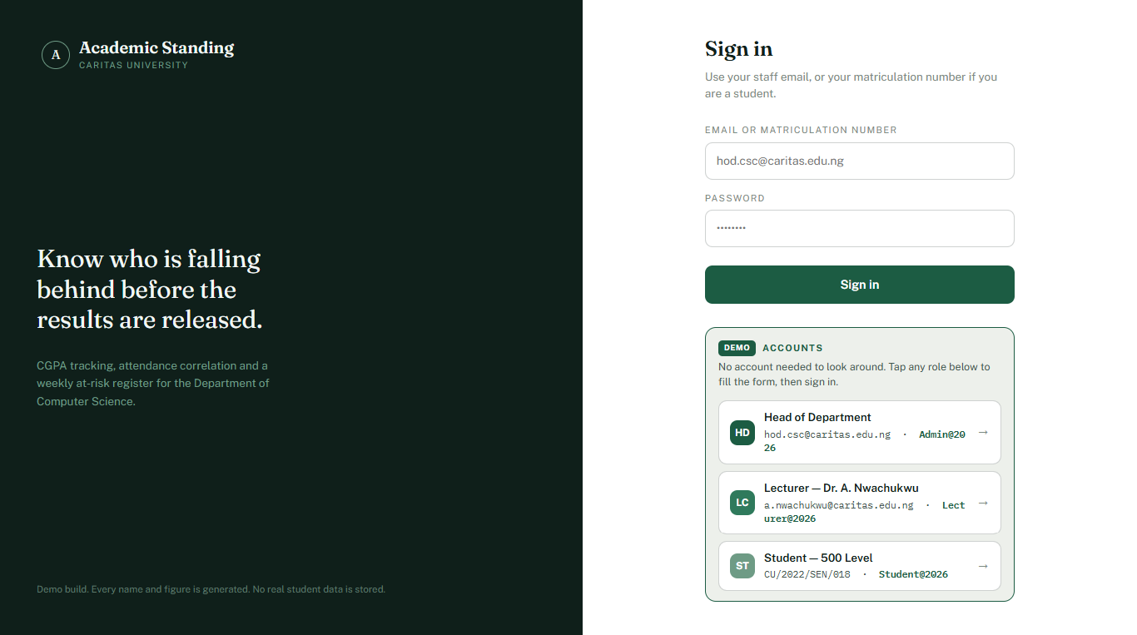
Plate 4.1: Role-Aware Sign-In Portal
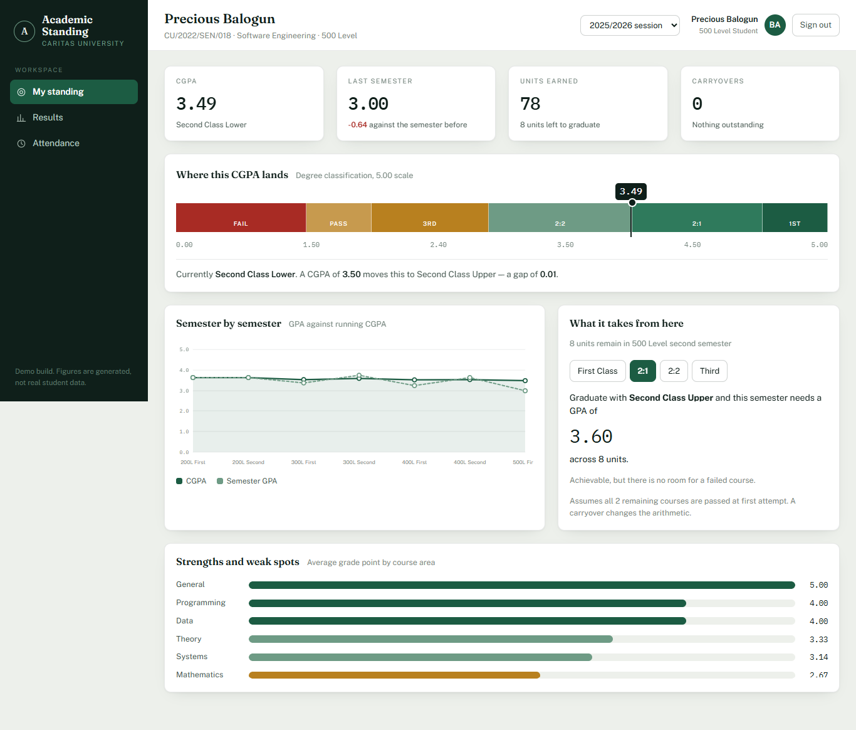
Plate 4.2: Head-of-Department Overview — Mean Standing, Attendance-CGPA Correlation and At-Risk Register
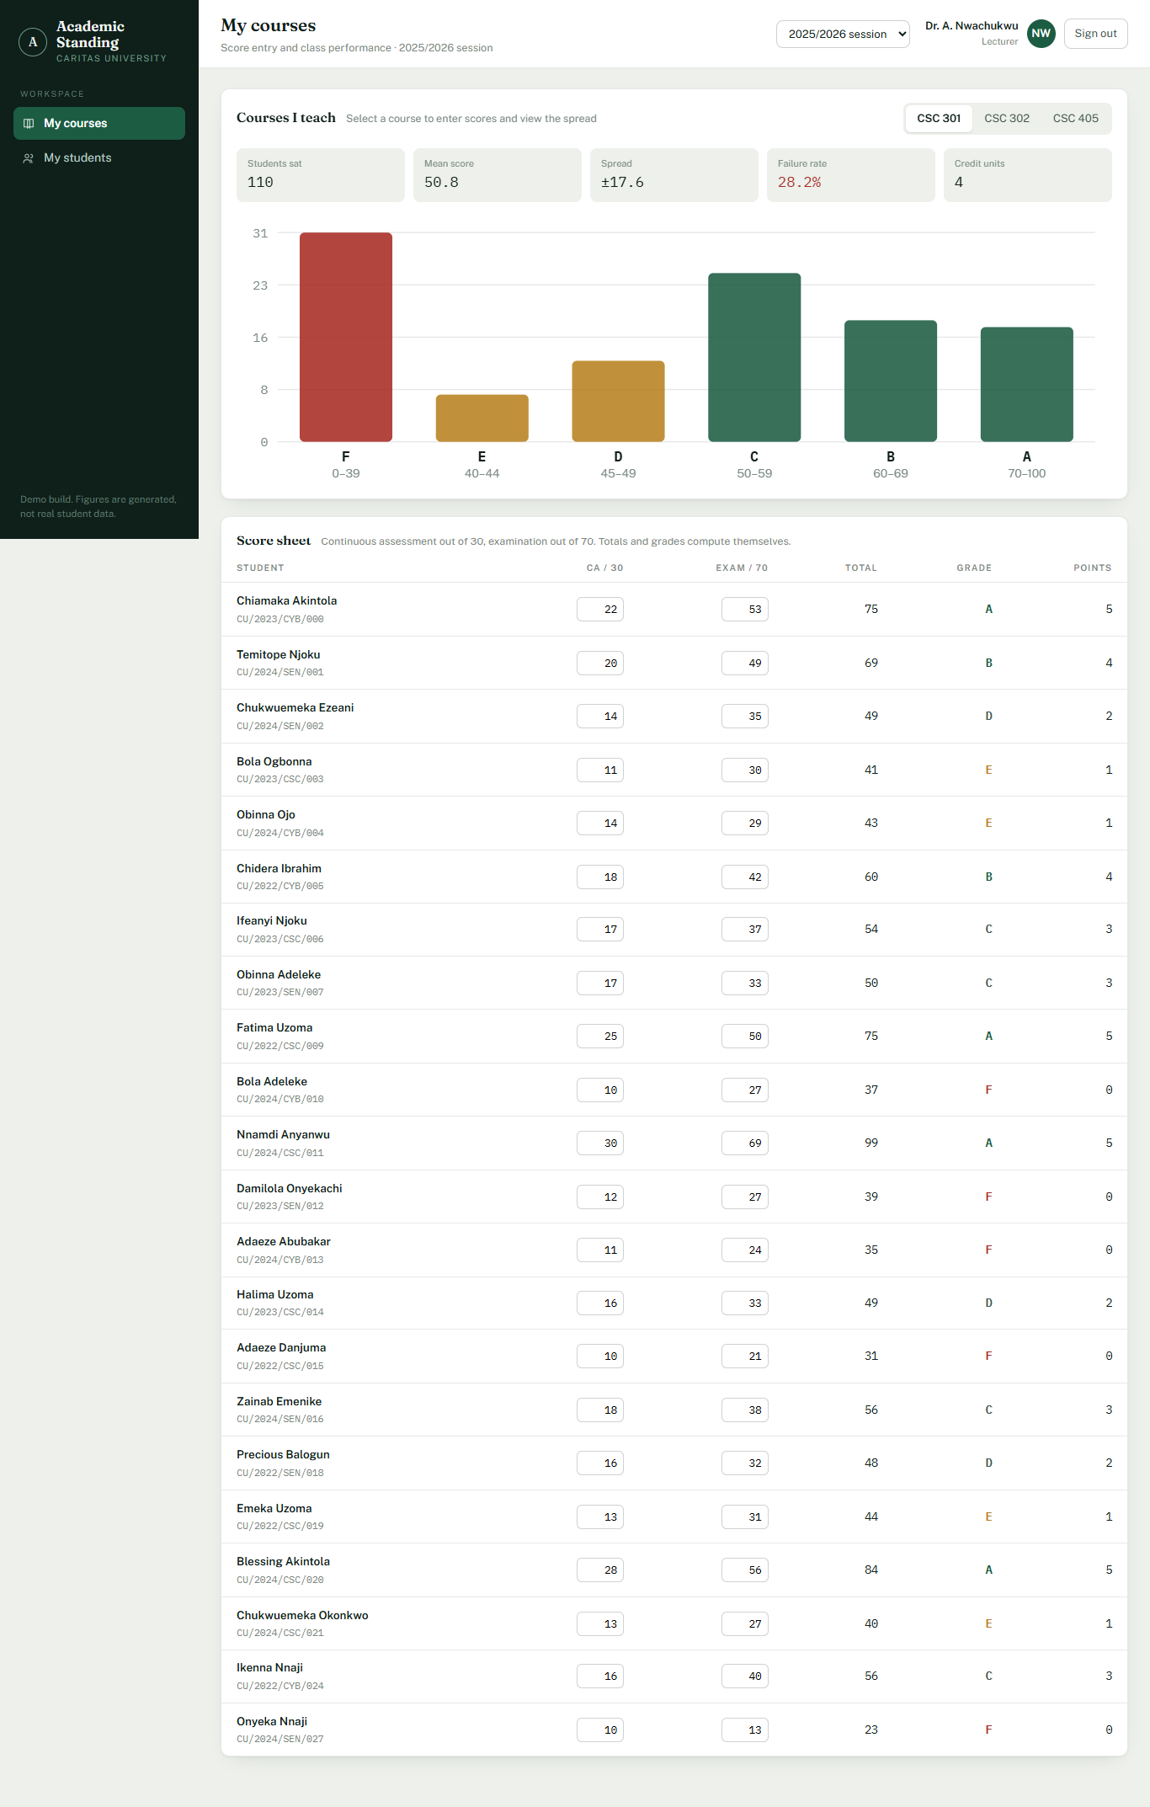
Plate 4.3: Lecturer Score Sheet with Live Grading and Grade Distribution
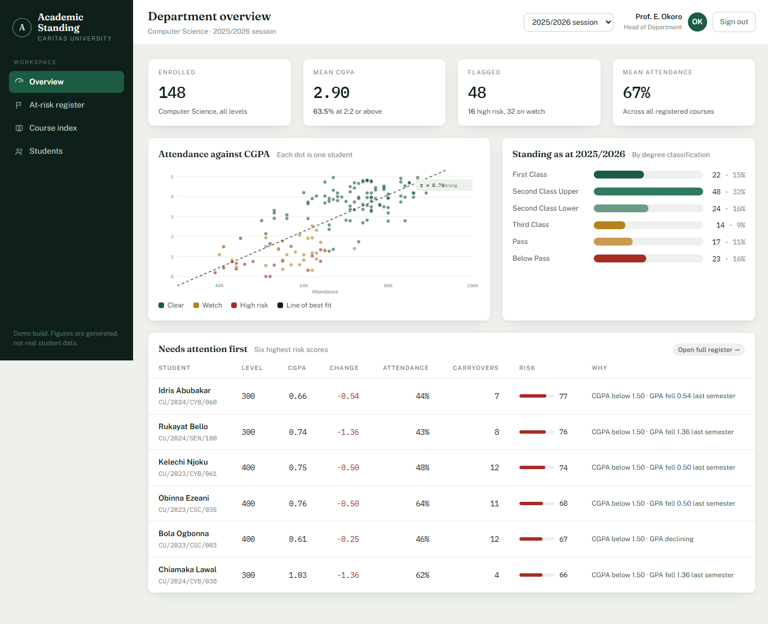
Plate 4.4: Student Standing — Degree Classification, Semester Trend and Projection

